Outline Format

Center cursor at the top of the page > Type: Outline > Hit Enter
In HOME tab > Set cursor to left margin. Type: Thesis:
Hit Enter
In the HOME tab > Click on Multilevel list dropdown > Click Define New Multilevel List…
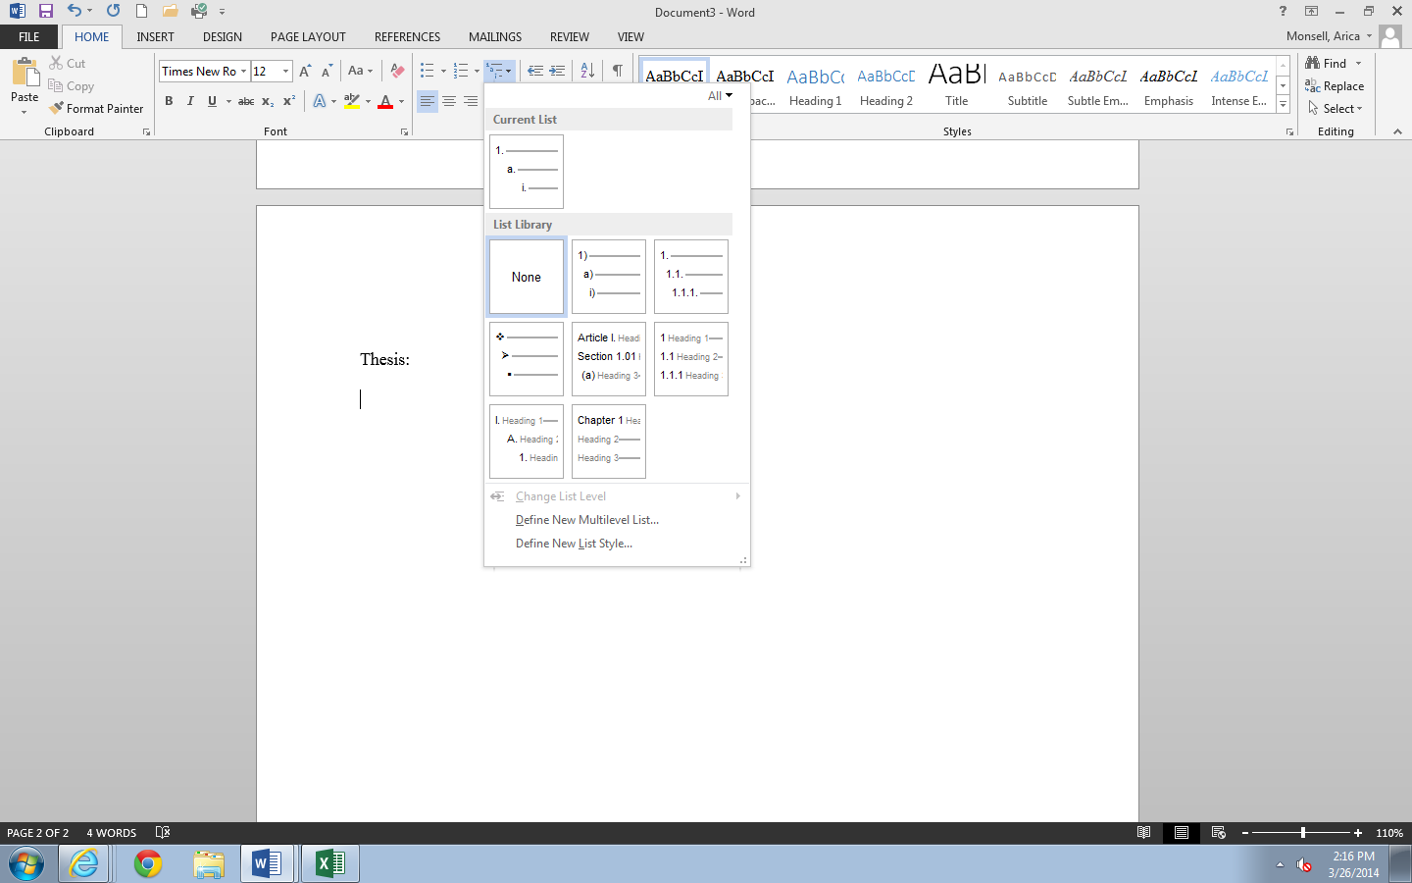
Follow the steps below then Save!

Step 1 Step 2 Step 3
Click on 3
Click in Enter formatting for number:
Hit Backspace to remove parenthesis then type a period (.)
Click Number style… drop down
Change to: 1, 2, 3,…
Click OK

Click on level 2
Click in Enter formatting for number:
Hit Backspace to remove parenthesis then type a period (.)
Click Number style… drop down
Change to: A, B, C,…

Level 1 should already be highlighted in blue
Click in Enter formatting for number:
Hit Backspace to remove parenthesis then type a period (.)
Click Number style… drop down
Change to I, II, III

SAVE!
Roman numeral one (I.) will automatically appear on the page. Click Save icon.

To test:
- Type: Main topic after I. hit Enter key. Roman numeral two should automatically show.
- Hit Tab key. Letter A should appear. Type: Supporting detail and hit Enter. Letter B should appear.
- Hit Tab key. Number one should appear. Type: Detail
- Hit enter. Number two should appear. Type: Detail.
- Hit Enter. Number three should appear.
- Hit Enter again Letter B should appear under A. Type: Supporting detail.
- Hit Enter. Letter C should appear.
- Hit Enter again. Roman numeral two should appear under I. Type: Main topic. Hit Enter again. Roman numeral three should appear.

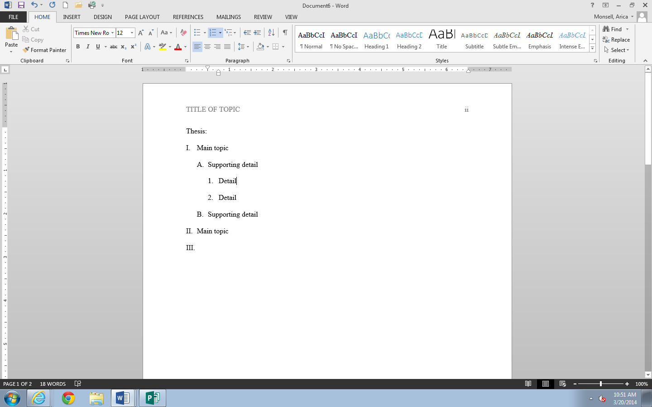
SAVE!

To format Abstract/ Body of the paper from here:

Go to INSERT tab. Click Page Break. Roman numeral three will jump to the next page.
Hit Backspace two times to erase it and set cursor at left margin.

