Cover Page (Vertical Center)

In the HOME tab > In Paragraph > Click Center

D

Go to the PAGE LAYOUT tab > click Page Setup corner arrow > click Layout tab
Change Vertical alignment to Center > Click OK
Type information teacher requested.
After the information is typed,…

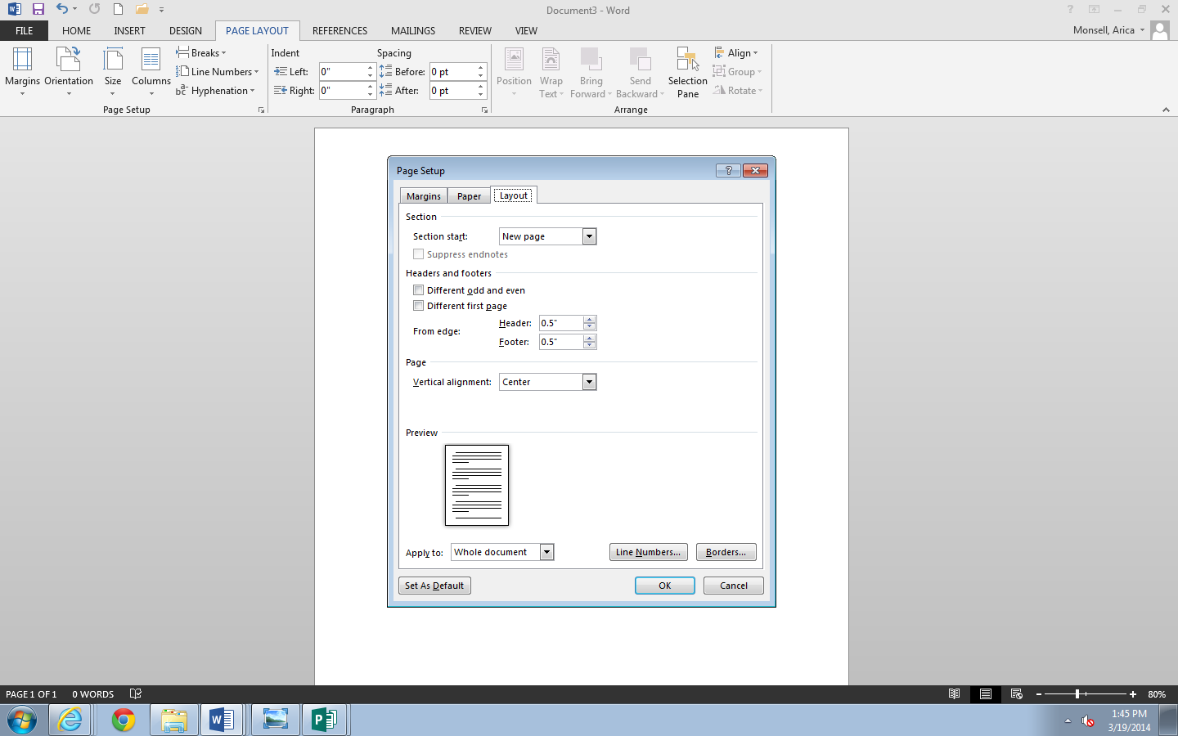

… keep cursor on the last line. Do NOT hit Enter
Go to PAGE LAYOUT > Breaks > Page. Cursor should jump to next page

Still in PAGE LAYOUT > Click Page Setup corner arrow > In Layout tab
Change Vertical alignment to: Top
Apply to: This point forward
Click OK
Cursor will jump to the top of the page
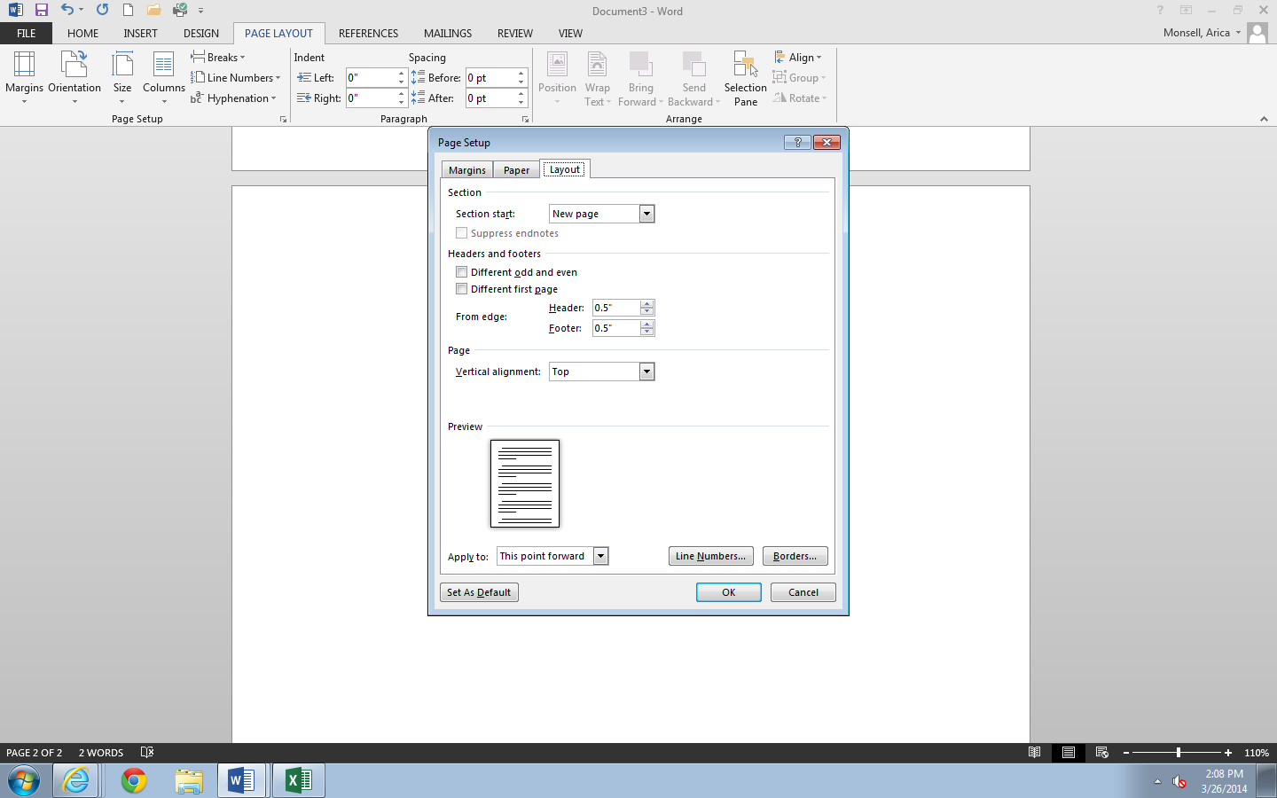
Click the Save icon

SAVE!

